HR Analytics Dashboard – Project Documentation
1. Project Overview
This project analyzes HR employee data using Microsoft Excel and Power BI to understand employee demographics, attrition patterns, income levels, education, job roles, departments, and work experience. The dashboard provides interactive visualizations to help identify important HR trends and support data-driven decision-making.
2. Tools Used
- Microsoft Excel – Data cleaning and preprocessing
- Microsoft Power BI – Data visualization and dashboard creation
3. Dataset
- Source: Sample HR dataset
- Data contains: Employee information including:
  - Department
  - Job Role
  - Gender
  - Age
  - Education
  - Income Band
  - Work Experience
  - Attrition
4. Steps Followed
- Collected and reviewed the HR dataset.
- Cleaned and prepared the data using Microsoft Excel.
- Checked and corrected missing or inconsistent data.
- Formatted the required columns for analysis.
- Performed basic analysis using Excel.
- Imported the cleaned dataset into Power BI.
- Created interactive charts and visualizations.
- Created KPI cards for important HR metrics.
- Added visualizations for:
  - Attrition by Department
  - Employees by Income Band
  - Employees by Education
  - Department-wise Employee Count
  - Attrition by Job Role
  - Attrition by Gender
  - Attrition by Age Group
  - Attrition Trend by Experience
5. Key Insights
- IT has the highest attrition count among departments, with 64 employees.
- Sales has the second-highest attrition count, with 53 employees.
- Operations has 52 attrition cases, followed by Finance, Marketing, and HR.
- Female employees account for 55.68% of the shown attrition, while male employees account for 44.32%.
- The 21–25 age group has the highest attrition count, with 57 employees.
- Employees with a Bachelor's degree form the largest education group, with 508 employees.
- The 30K–50K income band has the highest number of employees, with 492 employees.
- Among the displayed job roles, Data Analyst and Sales Manager have the highest attrition count at 23 each.
- The attrition trend generally decreases as work experience increases, with some fluctuations.
6. Dashboard Screenshots
The Power BI dashboard provides an interactive view of the HR data using charts, KPI cards, and filters.
Dashboard includes:
- Attrition by Department
- Employees by Income Band
- Employees by Education
- Department-wise Employee Count
- Attrition by Job Role
- Attrition by Gender
- Attrition by Age Group
- Attrition Trend by Experience

Figure 1: HR Analytics Dashboard created using Power BI :

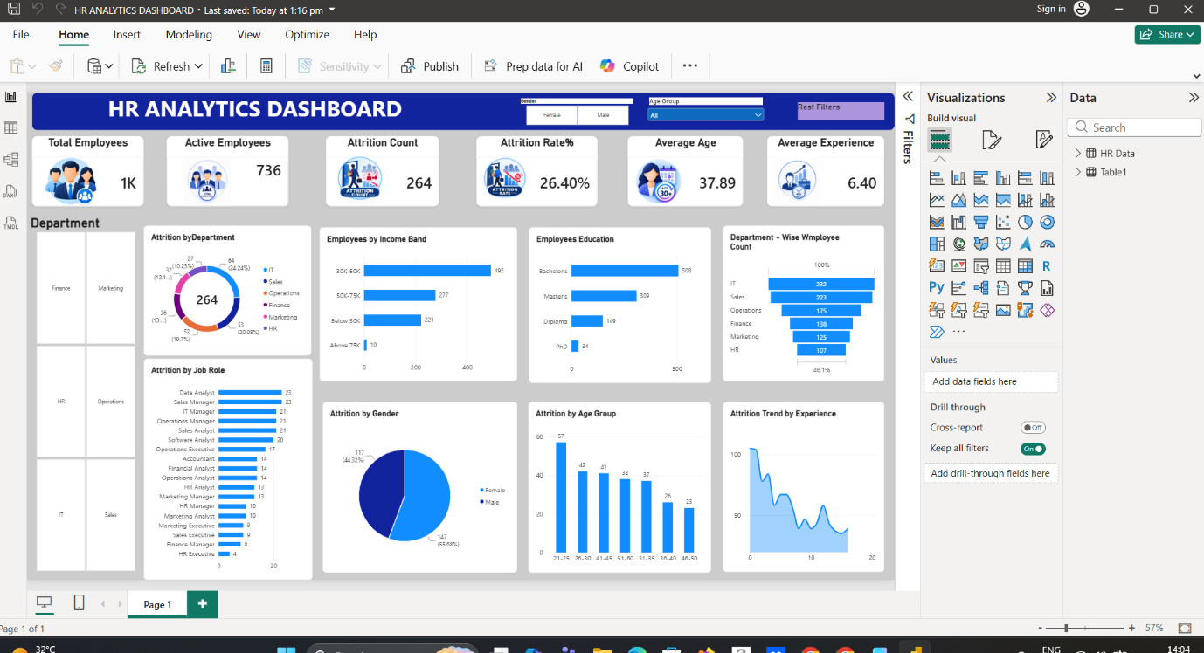
7. Files Included
- HR_Data.xlsx – Cleaned HR dataset and analysis
- HR_Analytics_Dashboard.pbix – Power BI dashboard
- README.md – Project documentation
8. How to Use
- Open HR_Data.xlsx in Microsoft Excel to view the cleaned dataset and analysis.
- Open HR_Analytics_Dashboard.pbix using Power BI Desktop.
- Use the available filters and interactive visuals to explore employee and attrition trends.

